2021 Leaving Cert Physics Paper (Higher Level)

2021 Question 1
In an experiment to determine the acceleration due to gravity, a student set up a simple pendulum of length 300 mm. The student suspended the pendulum from a fixed point, set it to oscillate, and measured the time t for 20 oscillations. This procedure was repeated for different lengths l of the pendulum.
The following data were recorded.

l (mm) | 300 | 400 | 500 | 600 | 700 | 800
t (s) | 22.0 | 25.4 | 28.4 | 31.1 | 33.6 | 35.9

- Draw a labelled diagram of how the apparatus was arranged in this experiment.
- Indicate on the diagram the fixed point of suspension
- Indicate on the diagram the the distance l.
- Why did the student measure the time for 20 oscillations rather than the time for one oscillation?
- Use the data to draw a suitable graph to calculate the acceleration due to gravity, g.
- Hence determine g.

2021 Question 2
In an experiment to determine the focal length of a concave mirror, a student first made an approximate measurement of the focal length of the mirror. He then measured the image distance v for each of two different object distances u.
The following data were recorded.
u (cm) | 20.0 | 25.0
v (cm) | 31.2 | 23.2

- Why did the student first make an approximate measurement of the focal length?
- How did the student determine the image positions?
- Draw a labelled diagram of how the apparatus was arranged.
- On your diagram, indicate u and v.
- Use all of the data to calculate the focal length of the mirror.
- Another student carried out this experiment but she measured the image distance v for each of six different object distances u.
She then drew a graph and used the graph to calculate the focal length.
Sketch a suitable graph that might have been drawn.
- How could this graph be used to calculate the focal length?

2021 Question 3
A student investigated how the fundamental frequency f of a stretched string varied with its tension T.
The string was kept at a length of 65 cm.
The following data were recorded.
f (Hz) | 256 | 320 | 341 | 427 | 480 | 512
T (N) | 15 | 24 | 27 | 43 | 54 | 61

- Draw a labelled diagram of how the apparatus was arranged in this experiment.
- Describe how the student used the apparatus.
- Draw a suitable graph to show the relationship between f and T.
- Use your graph to calculate the mass per unit length (linear density) of the string.

2021 Question 4
A student measured the resistance R of a wire of length 30 cm at different values of temperature Ɵ.
The following data were recorded.
Ɵ (⁰C) | 0 | 20 | 40 | 60 | 80 | 100
R () | 5.35 | 5.60 | 5.85 | 6.04 | 6.28 | 6.51

- Draw a labelled diagram of how the apparatus was arranged in this experiment.
- How did the student make the temperature of the wire 0 °C?
- Draw a suitable graph to show the relationship between R and Ɵ.
- Use your graph to determine the temperature when the resistance is 6 Ω.

- The student measured the diameter of the wire to be 2.4 mm.
How did the student measure the diameter of the wire?
- Calculate the resistivity of the metal at a temperature of 20 °C.

2021 Question 5
In an experiment to verify Joule’s law a constant current I was passed through a heating coil immersed in water. The current was allowed to flow for four minutes and the rise in temperature Δθ was determined.
This procedure was repeated for a number of different currents.
The mass of the water was kept constant at 105 g.
The following data were recorded.
I (A) | 1.0 | 1.5 | 2.0 | 2.5 | 3.0 | 3.5
Δθ (⁰C) | 2.0 | 4.6 | 8.2 | 12.6 | 18.3 | 25.0

- Draw a labelled diagram of how the apparatus was arranged in this experiment.
- Why was the current allowed to flow for a constant period of time?
- Draw a suitable graph to verify Joule’s law.
- Use your graph to calculate the average resistance of the heating coil.
(specific heat capacity of water = 4180 J kg^{‐1} K^{‐1})

2021 Question 6
Answer any eight of the following parts, (a), (b), (c), etc.
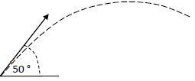
- Define acceleration. Hence derive the expression v = u + at.

- A ball is kicked with an initial velocity of 20 m s⁻¹ at an angle of 50° to the horizontal.
Calculate the horizontal distance it travels in 1.2 seconds.

- State the laws of equilibrium for a set of co‐planar forces.

- State an expression for the acceleration due to gravity at a distance of 2R above the surface of a planet of mass M and radius R.

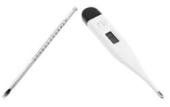
- Two different types of thermometer can give different readings when placed in the same environment.
Explain why this happens.
- Draw a labelled diagram to represent the second harmonic of a stationary wave in a pipe that is open at both ends.

- Calculate the sound intensity 6 m from a loudspeaker of power 20 mW.

- List two primary colours of light. What colour of light is produced when equal intensities of these two primary colours are mixed?

- Distinguish between earthing and bonding in domestic electricity.

- Draw a circuit diagram to show how voltage and current are measured for a diode in reverse bias.

- Carbon14 undergoes nuclear decay. The daughter nucleus is nitrogen14.
Write a nuclear equation for this decay.

- In terms of how they interact with the neutrons in a fission reactor, distinguish between a moderator and a control rod.

2021 Question 7

- State Newton’s second law of motion.
- State the principle of conservation of momentum.
- State the principle of conservation of energy.

An object A of mass 45 g is travelling at a horizontal speed of 6.2 m s^{–1} when it strikes a resting sphere of mass 80 g.
B hangs vertically at the end of a string, as shown in the diagram.
The string is free to move about point P which is 1.2 m above the centre of B.
During the collision, A and B are in contact for 25 ms.
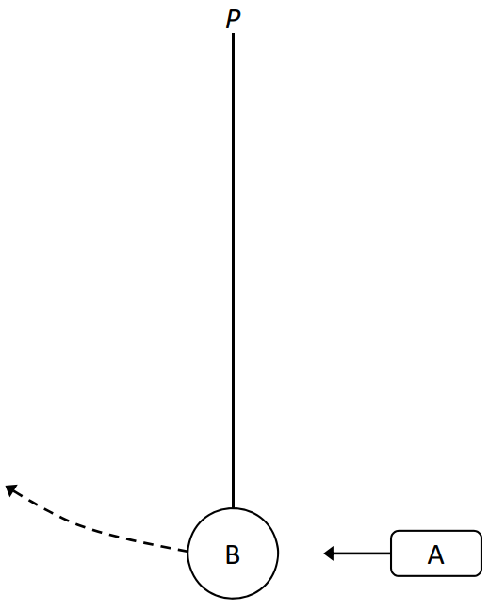
After the collision, A recoils with a speed of 1.1 m s^{–1}.

- Calculate the force exerted by B on A.
- Calculate the maximum velocity of B.
- Calculate the magnitude and direction of the maximum centripetal force on B.
- Calculate the maximum height gained by B.
- Calculate the maximum angular displacement of the string.
- Draw a labelled diagram to show the force(s) acting on B when it is at its maximum height.
- The string is cut at the instant B is at its maximum height.
What is the magnitude and direction of the acceleration of B after the string is cut?

2021 Question 8
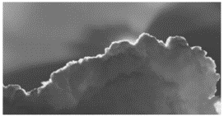The bright outline along the edge of a cloud – the ‘silver lining’– is an example of the diffraction of light in nature.
Diffraction is a wave phenomenon.
- What is meant by diffraction?
- A diffraction experiment can be used to demonstrate the wave nature of light. Describe such an experiment.
- What is a diffraction grating?
- Derive the diffraction grating formula, nλ = dsinθ.
- Calculate the angular separation between the two 3rd order images formed when blue light of wavelength 442 nm is incident on a diffraction grating of 600 lines per mm.
- Calculate the distance between these images on a screen placed 50 cm from the grating.
- What changes would be observed if the blue light was replaced with red light?
- What changes would be observed if the blue light was replaced with white light?
- Compare the wavelengths of radio waves with those of visible light.
- Why are radio waves not observed to undergo diffraction when incident on a diffraction grating of 600 lines per mm?

2021 Question 9
Ice is used as a coolant due to the high specific heat capacities of ice and water and the high specific latent heat of fusion of ice. It is the principal coolant used in ice packs for insulated picnic boxes, such as the one shown.
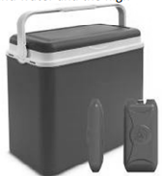
- What is meant by specific heat capacity?
- Why does the high specific latent heat of fusion of ice make it a good coolant?
- Suggest two reasons why the walls of a picnic box are made from hollow plastic rather than solid plastic.

A picnic box contains food items with an initial temperature of 10.5 °C. The heat capacity of the food is 17.8 kJ K^{–1}.
An ice pack that contains 250 g of ice was taken from a freezer held at a temperature of – 18 °C and placed in the picnic box. As the temperature of the ice increases and it melts, the temperature of the food decreases.

- Calculate the final temperature inside the picnic box when its contents have reached thermal equilibrium.

Freezers and refrigerators operate by use of a heat pump.
- Draw a labelled diagram of a heat pump.
- Explain how a heat pump works.

A student used the apparatus shown below to investigate how heat travels through water.
- What observations did the student make?
- What conclusion could the student have made?

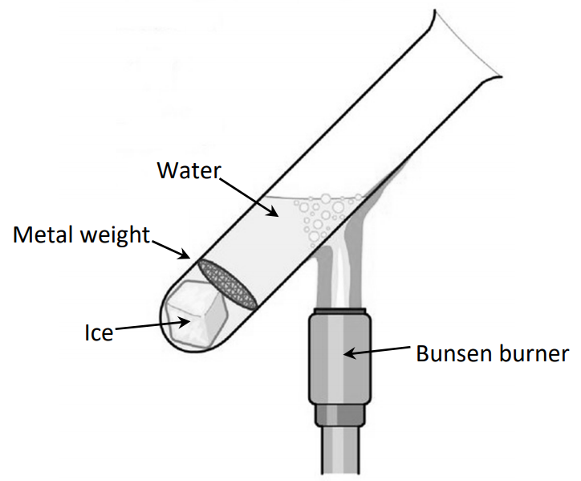

(specific heat capacity of ice = 2100 J kg^{–1} K^{–1}; specific heat capacity of water = 4180 J kg^{–1} K^{–1}) (specific latent heat of fusion of ice = 3.3 × 10⁵ J kg^{–1})

2021 Question 10
A current flowing through a conductor creates a magnetic field around it.
- What is a magnetic field?
- Describe an experiment to show the magnetic field around the conductor.
- Draw the shape and direction of this magnetic field.

When placed in an external magnetic field, a current-carrying conductor may experience a force.
- The magnitude of this force depends on a number of factors. Name three of them.
- Derive an expression for the force F experienced by a charge q travelling with velocity v perpendicular to a magnetic field of flux density B.

A square loop of side 5 cm enters a magnetic field of flux density 0.4 T while travelling at a velocity of 6 m s⁻¹ parallel to one side of the square. The square is perpendicular to the direction of the field.

- Use Faraday’s law of electromagnetic induction to calculate the average emf induced in the loop as it enters the field.
- The other law of electromagnetic induction is Lenz’s law. State Lenz’s law.
- Explain how Lenz’s law is a special case of the principle of conservation of energy.

2021 Question 11
The photograph shown was taken during a meeting of the Deutsche Bunsen-Gesellschaft (German Bunsen Society) in 1932.
The three people sitting at the left of the table are James Chadwick, Hans Geiger and Ernest Rutherford. Lise Meitner and Otto Hahn are standing behind Rutherford. The careers of Chadwick and Geiger were very similar.
They both worked under Rutherford early in their careers. Later they were on opposite sides in the efforts to build the first nuclear bombs, Chadwick with the Manhattan Project in America and Geiger with the Uranium Club in Germany. Shortly before this photograph was taken, Chadwick had discovered the neutron.
In his experiment an alpha particle was absorbed by a beryllium–9 nucleus and a neutron was emitted.
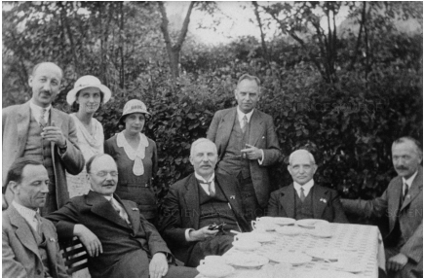

  - Write the nuclear equation for this event.
  - Calculate the increase in kinetic energy during this event.
  - Geiger is best remembered for co‐inventing the Geiger‐Müller tube.
A G‐M tube and a solid‐state detector have the same function. What is this function?
  - Describe, with the aid of a labelled diagram, the principle of operation of a detector of this sort.
  - While working with Rutherford, Geiger assisted on the gold foil experiment.
Describe with the aid of a labelled diagram the gold foil experiment.
  - What observations were made during the experiment?
  - What did Rutherford conclude about the structure of the atom?
  - How did Niels Bohr improve Rutherford’s model to explain emission line spectra?

2021 Question 12
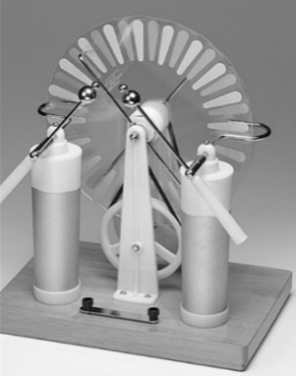
The Wimshurst machine is an electrostatic generator for generating high voltages. It uses the principles of charging by induction and point discharge to store energy in two large capacitors.
Wimshurst machines provided be a source of high voltage for early X‐ray tubes.

- Describe a laboratory experiment to demonstrate charging by induction.
- Explain how point discharge occurs.

- The plates of a parallel plate capacitor of capacitance 3.2 pF have a common area of 20 cm² and are 15 mm apart.Calculate the relative permittivity of the capacitor’s dielectric.

- What would be the effect on the capacitance if the distance between the plates was doubled?
- Three such capacitors are connected in parallel as shown below.
Explain why the effective capacitance of this combination is 9.6 pF.
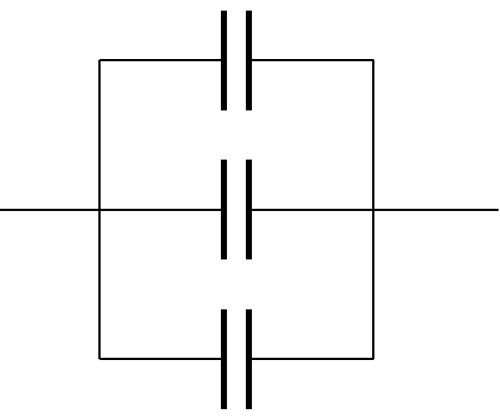
- Draw the electric field pattern in a charged parallel plate capacitor.

A voltage of 20 kV is applied between the cathode and the anode in an X‐ray tube.
- Why is the cathode of an X‐ray tube hot?
- Calculate the maximum speed of an electron as it moves between the cathode and the anode.
- What happens to the energy of the electrons when they hit the anode?

2021 Question 13
Answer either part (a) or part (b).

(a) Read the following passage and answer the accompanying questions.
In the beginning, nearly 14 billion years ago, all the space, matter and energy of the universe was contained in a volume less than one trillionth the size of the full stop that ends this sentence. The forces of nature that define the universe were unified. As the universe rapidly expanded within a fraction of a second, in what is known as the Planck era, this unified force split into the four distinct forces that we now understand. At this time, matter in the form of subatomic particles and energy in the form of photons incessantly interplayed. Photons converted into matter‐antimatter pairs which immediately annihilated returning their energy back to photons. The universe was now a seething soup of quarks and leptons. As it continued to expand and cool quarks joined to form new particles called hadrons. At this stage the universe had expanded to a few light years across and one second had elapsed.
In CERN a circular particular accelerator called the Large Hadron Collider is being used to recreate these conditions.
Adapted from ‘Astrophysics for People in a Hurry’ (Neil deGrasse Tyson) W.W. Norton & Company 2017

- State the quark composition of the proton.
- List the forces experienced by a proton in decreasing order of strength.
- The Planck constant relates energy and frequency. Its value is 6.6 × 10^{–34} J s.
Express this unit in terms of metres, kilograms and seconds.
- Write a nuclear equation for the pair annihilation of a proton and an antiproton.
- A photon produces a muon anti‐muon pair. Calculate the minimum energy of the photon in electronvolts.
- In the Large Hadron Collider, how are the particles (a) accelerated, (b) maintained in circular motion?
- In 1932 Walton and Cockcroft manufactured one of the first useful particle accelerators.
State two reasons why their experiments using this accelerator were of scientific significance.

2021 Question 14
Answer any two of the following parts, (a), (b), (c), (d).

2021 Question 14 (a)
An iron sphere of mass 40 g hangs from a spring and oscillates with simple harmonic motion.
The period of oscillation is 0.74 s.
- What is simple harmonic motion?
- Calculate the spring constant.
- Calculate the acceleration of the sphere when its displacement is 18 mm from its equilibrium position.

The iron sphere and the spring are brought to rest and a small magnet is attached to the sphere.
When the magnet is attached to the sphere, the length of the spring increases by 15 mm.
- Calculate the mass of the magnet.
(acceleration due to gravity = 9.8 m s^{–2})

2021 Question 14 (b)
Hydroacoustics is the study of sound in water. The Doppler effect is observed in hydroacoustics.
- What is the Doppler effect?
- Describe how the Doppler effect can be demonstrated in the laboratory.
- A moving underwater source emits a sound of frequency 800 kHz while travelling towards an underwater detector, which detects a frequency of 806 kHz.
Calculate the speed of the source.
- Sound travels faster in water than in air. When a sound wave travels from water into air, it undergoes refraction.
Draw a ray diagram to show the refraction of a sound wave as it travels from water into air.
(speed of sound in water = 1480 m s^{–1})

2021 Question 14 (c)
In the photoelectric effect electrons are emitted from the surface of a metal when the incoming light of intensity I has a frequency f that exceeds a certain value f_{o}, the threshold frequency.
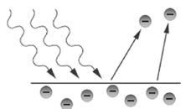
Describe what happens when
- f > fo , f is constant and I is increasing,
- f > fo , f is increasing and I is constant,
- f < fo , f is constant and I is increasing.

Light of wavelength 440 nm is incident on a metal that has a work function of 2.6 eV.
- Calculate the threshold frequency of the metal.
- Calculate the maximum speed of the emitted electrons.

2021 Question 14 (d)
Ball lenses are glass spheres which can be used for special effects in photography.
Light travels at a different speed in air and in glass.
  - The photograph shows the inverted image of a mountain formed in a ball lens.
Draw a ray diagram to show how an inverted image is formed in a lens.
  - Is the image real or virtual?
  - The critical angle of the glass in a ball lens is 41.4°.
What is meant by critical angle?
  - Calculate the speed of light in the ball lens.
  - Explain why white light is dispersed as it passes through the ball lens.

